Testing
Test Number | Purpose of test | Test Data | Expected Result | Actual Result | Comments
1 | Range Check - checks if customer phone number, is within the range of values specified. (15) | 0576245225 (phone num)  NORMAL | Data should be accepted, and entered into the database when the user presses save and exit. | Data is accepted, and is passed into the database if all other fields are filled. | PASS
2 | Range Check - checks if price is within range of values specified. (10000) | 12330.00  ABNORMAL | Data should not be accepted, and should return an error to the user. | Data is accepted, and is passed into the database, if all other fields are filled. | FAIL  This failed because of the lack of validation regarding the price, the boundaries were not defined. I fixed this by adding validation to the price field, checking if the values are within a certain range.
3 | Range Check - checks if trip duration is within range of values specified (50) | 50  EXTREME | Data should be accepted, and should be entered into the database. | Data is accepted, and passed into the database, if all other fields are filled. | PASS  This was within the range of specified values.
- 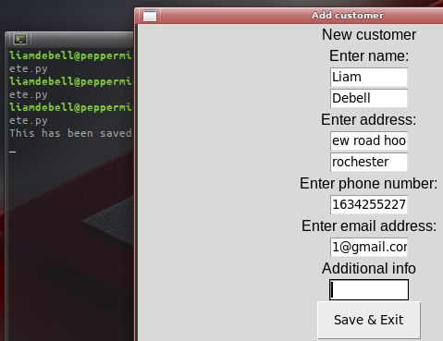2. 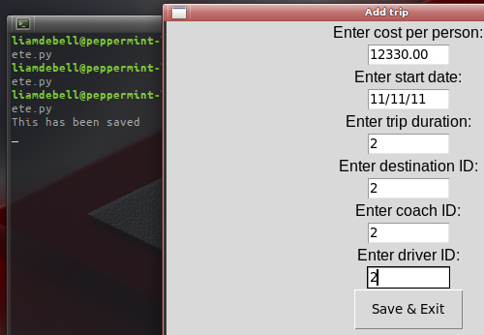3.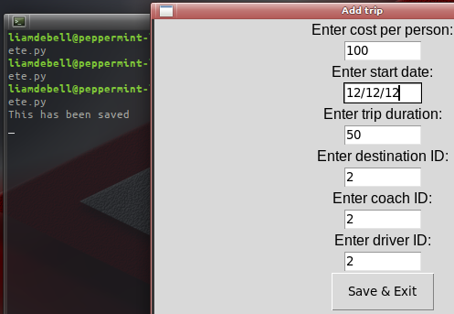
4 | Presence Check - Is data in specified field? (destination and hotel name) | NONE  ABNORMAL | User should be prompted that there is no data in the field, and returned to enter it again. | The blank data was accepted as valid and was inserted into the database. | FAIL  This happened because there is no validation in this specific field to check if data is present. This will be fixed by adding validation to presence.
5 | Presence Check - Is data in specified field? (destination and hotel name) | Swish Hotel  NORMAL | Data should be passed into the database as long as all fields are populated. | The data was passed into the database alongside all of the other fields being filled. | PASS
6 | Presence Check - Is data in specified field? (special need) | NONE  EXTREME | Data should be automatically checked and if data is not present, then it should be replaced with ‘None’ in the database. | The data was checked and replaced with ‘None’ in the database, removing blank entries from data. | PASS
4. 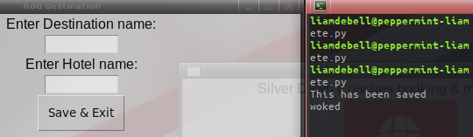5.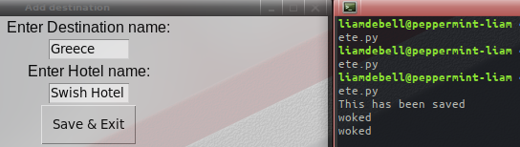6.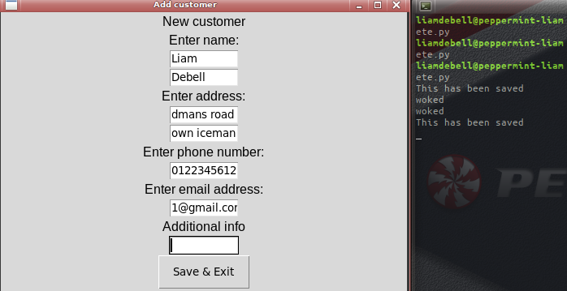
7 | Format Check - Checking if any data type is supported. (customer_id and trip_id) | Words  ABNORMAL | Data should not be allowed to enter into database, due to value error. | Data failed to enter into database, due to a constraint error with foreign keys. This data will never be allowed to enter. | PASS
8 | Format Check - Checking if any data type is supported. (customer_id and trip_id) | 99  EXTREME | Data should be allowed to enter, as it is at the boundary of accepted values. | Data entered successfully, and was allowed to be passed into the database. | PASS
9 | Format Check - Checking if any data type is supported. (customer_id and trip_id) | 6  NORMAL | Data should pass into the database successfully and prompt the user with success. | Data was entered successfully and was allowed to pass into the database. | PASS
7. 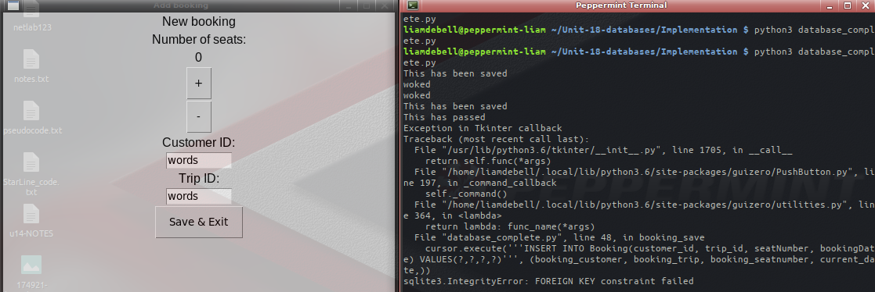8.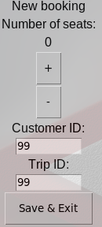9.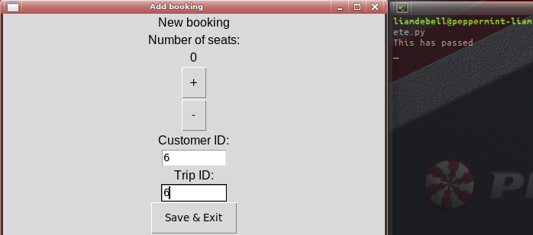
10 | Integrity Check - Testing that data cannot be entered if data does not exist in the original destination. (booking table) | 120  ABNORMAL | Data should not be allowed to enter, as it returns a foreign key constraint, nothing should be returned to the user. | Data cannot be entered, as it returns a foreign key constraint. | PASS
10. 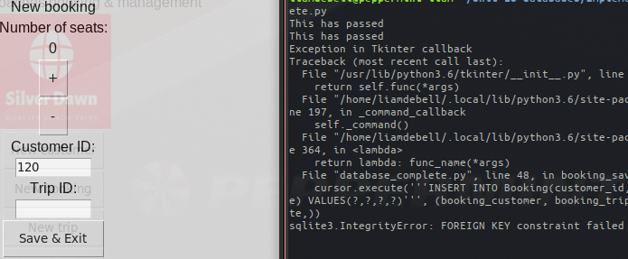
7 | Form 1 - input form to register a new customer | Name: Liam  Surname: Debell  Address1: bridgeroad  Address2: hello city  Phonenum: 1234567890  Email: liamdebell11@gmail.com  Additional Info: None | Data should be allowed to enter into the database, and should appear in the customer table alongside a unique key. | Data is accepted, and put into the customer table into each of the appropriate fields, a unique primary key is supplied and associated with the record. | PASS
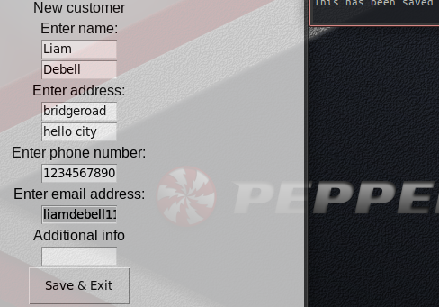
8 | Form 2 - input form to add new booking | Number Of Seats: 2  CustomerID: 3  TripID: 2 | Data should be allowed to enter, and should populate all of the appropriate fields. | Data is stored in the booking table, and the date is automatically generated from the system time, allowing all fields to be filled. | PASS
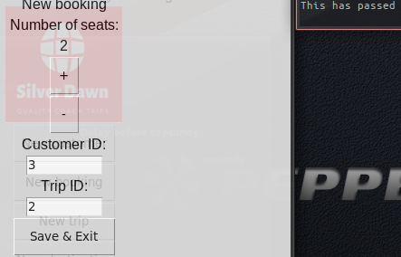
9 | Query 1 - A query to retrieve the details for all passengers on the Christmas market trip to Lincoln on 16th December 2019. |  | SELECT Trip_id from Trip INNER JOIN Destination ON Destination.destination_id = Trip.destination_id where destName = 'Lincoln Xmas Market'  SELECT customer_id FROM Booking where trip_id=? | The first query should cause the trip id to be returned, and from that the customer id’s associated with that in the booking table should be returned from the second query. | The first query should cause the trip id to be returned, and from that the customer id’s associated with that in the booking table should be returned from the second query.
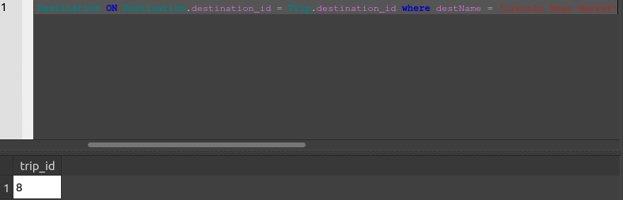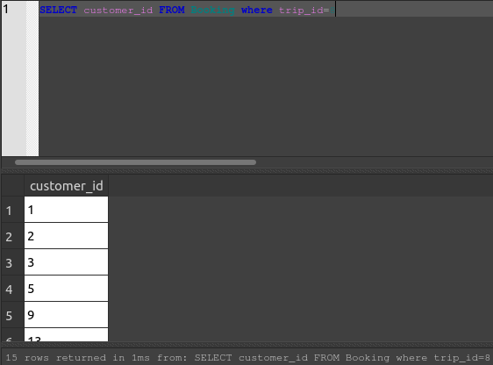
10 | Query 2 - A query to display all trips currently available for booking, displayed in chronological order (most recent first). |  | SELECT destName, startDate, personCost, duration FROM Trip INNER JOIN Destination on Destination.destination_id = Trip.destination_id ORDER BY startDate | This query should return destname, startdate, personcost and duration from trip and destination, this data should be ordered by start date. | This query should return destname, startdate, personcost and duration from trip and destination, this data should be ordered by start date.
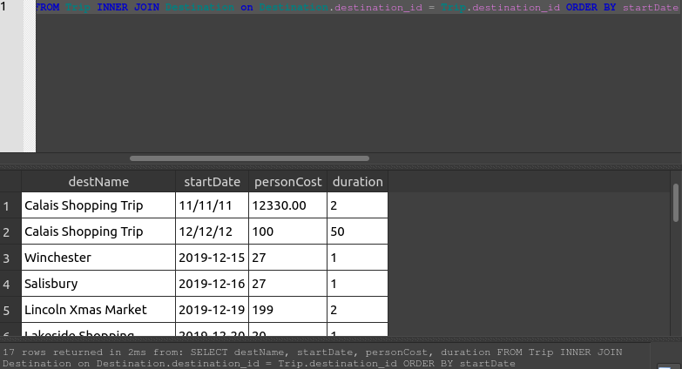
11 | Query 3 - Mike wants to leaflet-drop all customer addresses in the E5 postcode area. Produce a list that can be printed that can be used to accomplish this. |  | SELECT AddressLine1, AddressLine2, Postcode FROM customer WHERE Postcode LIKE 'E5%' | This should collect both addresses and postcode of customers only where the post code contains E5. | The query returned all of the customer details where the postcode contained E5.
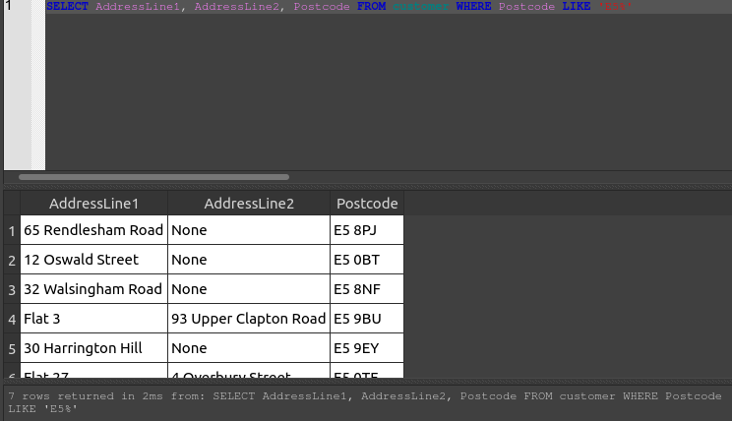
12 | Query 4 - Mike would like the functionality to see current income for any trip currently in the system. Can a calculation be produced for this? |  | SELECT SUM(seatNumber) FROM Booking where trip_id=?  SELECT trip_id, personCost, (personCost)*? FROM Trip INNER JOIN Destination on Destination.destination_id = Trip.destination_id WHERE trip_id = ? | The first query should retrieve the sum of all of the number of seats where the trip_id is equal to 8 (in this case), and the second query returns the personcost multiplied by the sum of the seatnumer from the first query, this then retrieves the trip_id, person cost and personcost*29 (in this case.) | The first query did retrieve the sum of all of the number of seats where the trip_id is equal to 8 (in this case), and the second query returns the personcost multiplied by the sum of the seatnumer from the first query, this then retrieves the trip_id, person cost and personcost*29 (in this case.)
